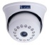
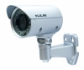
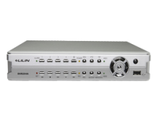
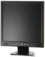
Indoor Camera Outdoor Camera DVR / NVR Monitor

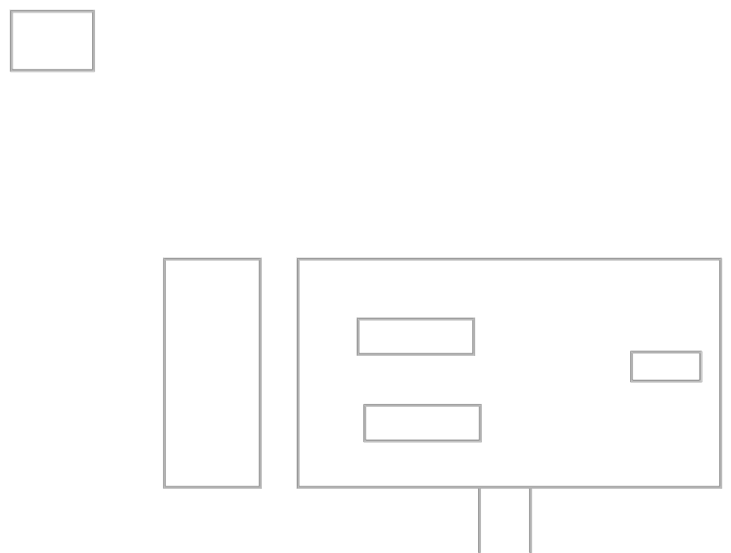
Customer Name | Postal Department
Drawing Title | CCTV System
Issue No | RE/TE/165
Issue Date | 21/02/2018
Revision No
Revision Date
Created By | Priyantha Rathnasinghe
Approved By | Deemanth Munasinghe

X- Ray
Room

7th Floor
DVR
Entrance

